docker build -t my-static-site .
>> docker run -d -p 8080:80 my-static-site
docker run -d -p 8080:80 my-static-site
docker ps
docker build -t my-static-site

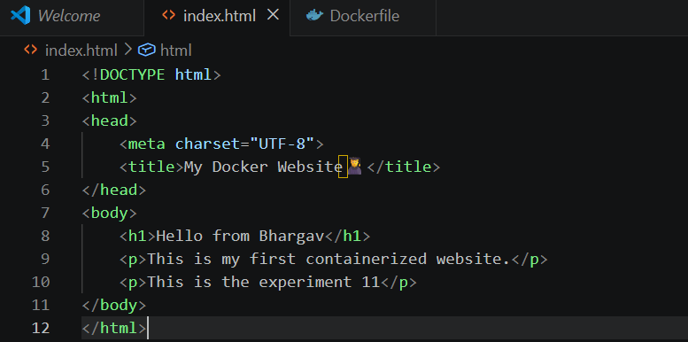http://localhost:8080/


